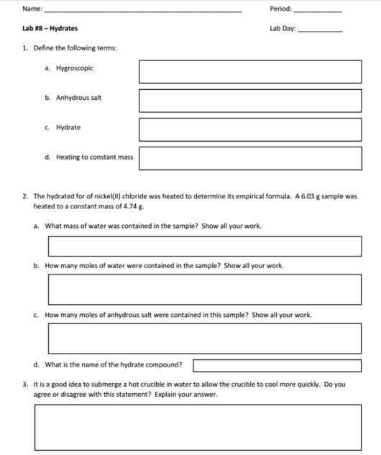

It is not a good idea to submerge a hot crucible in water to allow the crucible to cool more quickly because the high temperature difference will cause the crucible to shatter. The surface of the crucible will cool when in contact with the water, but the insides of it are still hot. This causes the crucible's surface to contract while the inside stays the same, causing the shatte.r

Nickel(II) chloride dihydrate

or about 0.037 moles.

or about 0.071 moles.

6.03g nickel chloride hydrated- 4.74g constant mass = 1.29g of water

Heating a hydrate until its mass from the current heating is equal or very close to the previous heating.

The water-inclusive compounds that form from hygroscopic compounds

The hygroscopic compound without the water.

Ionic compounds that naturally take in water

B2

Jonathan Quang 5-6